**PLACEMENRS ANALYTICS AND DASHBOARD**

**Mr. Dinesh1, Ms. Harika2, Mr. Sunand3, Mr. DhayananadKumar4,**

**Mr. Naveen5, Mrs.Surekha6**

1B. Tech Student, Department of CSE, Sri Vasavi Engineering College(A), Pedatadepalli, Tadepalligudem – 534101.

2B. Tech Student, Department of CSE, Sri Vasavi Engineering College(A), Pedatadepalli, Tadepalligudem – 534101.

3B. Tech Student, Department of CSE, Sri Vasavi Engineering College(A), Pedatadepalli, Tadepalligudem – 534101.

4B. Tech Student, Department of CSE, Sri Vasavi Engineering College(A), Pedatadepalli, Tadepalligudem – 534101.

5B. Tech Student, Department of CSE, Sri Vasavi Engineering College(A), Pedatadepalli, Tadepalligudem – 534101.

6B. Tech Student, Department of CSE, Sri Vasavi Engineering College(A), Pedatadepalli, Tadepalligudem – 534101.

**Email**: [dineshgonnuri@gmail.com](mailto:dineshgonnuri@gmail.com)

**Corresponding authors Email:**  [harikagogga71@gmail.com](mailto:%20harikagogga71@gmail.com) ,

[praveensunand143@gmail.com](mailto:praveensunand143@gmail.com),

[udimiudidayanandkumar@gmail.com](mailto:udimiudidayanandkumar@gmail.com)

[naveenandugula2004@gmail.com](mailto:naveenandugula2004@gmail.com)

[surekhakatti111@gmail.com](mailto:surekhakatti111@gmail.com),

**Abstract:** The **"Placements Analytics and Dashboard"** is a comprehensive web application designed to store and analyze placement data for students who have secured positions in software companies. Now a days there are various technologies and opportunities in the software field so in order to get placed in a well-established software company we need to find out which of them are well-established companies and technologies that need to be learnt by the students. This system offers powerful analytical features that enables users to enhance statistical reports and visualizations. A pie chart representation showcases the distribution of placements based on the technologies learnt by students. This visualization acts as a guide for students to identify the most sought-after skills in the industry to empower them and make informed decisions regarding their educational and career paths. Furthermore, the project includes a comparative analysis of placement trends year by year, depicted through bar graphs and a pie chart representation of hiring companies that illustrates the number of students recruited by each Organisation valuable insights and industry preference.

**Keywords:** Analysis and Dashboard, Web application Placements Data (YEAR BY YEAR), Visualizations, Pie Charts, Bar Graphs, Statical Reports, Database

**1.Introduction:**

In many institutions there is mostly no data of previous projects. This Platform **"Placements Analytics and Dashboard"** seeks to address the lack of a centralized repository for accessing student data. This website will serve as a comprehensive repository of student data, allowing the students to explore and search for the courses they need to complete in order to secure a job in best companies and to find information about those who have been previously employed.

Increasing opportunities and technologies in the software field demands informed career choices for students. The “Placements Analytics and Dashboards” is a web application that addresses the need by analysing placement data for students in software companies.

This web application project will empower students with data-driven insights to identify sought-after skills in the industry, offering powerful analytical features such as pie charts and bar graphs for enhanced statistical reports and visualizations.

This project will also facilitate comparative analysis of placement trends year by year and showcases company preferences for requirement. This comprehensive tool guides students towards successful education and career paths in the Software Industry.

**2.Literature Survey:**

In the past few years, there has been a surge in the demand for skilled professionals in the software industry, leading to a rise in placement analytics and dashboard solutions. This trend highlights the growing importance of employing effective strategies for acquiring, analyzing, and utilizing this crucial data. While various studies and surveys have been conducted in recent years to understand the trends and challenges in the software industry. This review may help us to describe some preliminary research that was caried out by several authors on this relevant work. Now we are going to consider some important guidance and keywords to further expand our work:

**Placement Analytics for Software Engineering Students by Kumar et al. (2020)** This research paper introduces a dashboard that leverages data mining and machine learning techniques to analyze placement data specific to software engineering students. The primary goal is to offer valuable insights into the job market for these students, helping them make informed career choices. The dashboard provides information on popular technologies that are in demand in the job market, crucial skills, and top companies in the software engineering field.

**Web-Based Placement Analytics System for Engineering Colleges by Rathore et al (2019)** Rathore et al.'s work focuses on a web-based system designed to collect and analyze placement data from engineering colleges. This system offers comprehensive reports on various aspects of placement, such as trends over time, the companies that frequently recruit from these colleges, and the skills that are highly sought after by employers. This research is valuable for colleges and students aiming to improve their placement outcomes.

**Singh et al.’s (2018) Data-Driven Approach to Placement Analytics** Singh et al.'s research paper outlines a data-driven framework for enhancing the placement process. The framework encompasses the entire process, including data collection, data cleaning, data analysis, and data visualization. By systematically addressing each of these stages, this approach aims to provide a more efficient and data-backed placement process. It can be seen as a roadmap for institutions looking to improve their placement procedures through data analytics.

**Study on Placement Trends in the IT Industry" by Raj et al. (2017)** Raj et al.'s study focuses on analysing placement trends within the IT industry over a five-year period. The research identifies and highlights the most popular technologies sought after by IT companies, including Java, Python, and C++. Furthermore, it emphasizes the importance of certain skills such as problem-solving, communication, and teamwork that are in high demand among IT employers. This study is beneficial for both students seeking IT careers and educational institutions preparing students for the job market.

**Comparative Analysis of Placement Trends in India and the US" by Sharma et al. (2016)** Sharma et al.'s research is a comparative analysis of placement trends in the IT industry between India and the United States. This study explores the differences and similarities in the job markets of these two regions. It identifies the popular programming languages like Java, Python, and C#, as well as key skills such as problem-solving, communication, and creativity, which are valued by employers in each location. Understanding these regional variations can be valuable for students and professionals considering international job opportunities or companies looking to expand their workforce globally.

These research papers collectively offer a comprehensive view of placement analytics and trends in the software engineering and IT industries, providing valuable insights for students, educational institutions, and recruiters in the field.

**3.Proposed Work:**

**3.1 Proposed System:**

The comprehensive system incorporates multiple vital components, beginning with a resilient data storage and management system engineered to safeguard a substantial amount of placement data. This data encompasses student profiles, company details, and technology-related information. Collaborating with this component is a sophisticated data analysis engine, adept at processing the data and generating thorough statistical reports and visualizations. These reports and visualizations are effortlessly accessible through a user-friendly web-based interface, facilitating seamless engagement for students, educators, and career advisors.

Inside this interface, students can not only input their own data but also obtain insights from pie charts showcasing the distribution of placements based on their acquired technologies. This analysis assists students in pinpointing the most coveted skills. The system also features year-by-year placement trend analysis, as depicted by bar graphs and trend charts. This historical perspective empowers students and institutions to make informed, data-driven decisions regarding educational and career paths. Furthermore, a pie chart or similar visualization displays the number of students recruited by various organizations, offering valuable insights into industry preferences and the stature of well-established companies.

We are going to implement a comprehensive web application designed to store and analyze placement data for students who have secured various jobs in various positions in software companies.

The System aims to address these shortcomings by providing powerful **Technology Distribution Analysis (Pie charts and Bar Graphs), Interactive Visualizations and Automated Comparative Analysis** to guide students and improve the management of placement data.

The **“Centralized Data Repository”** will centralize all placement-related data in a structured database, ensuring that all relevant information is easily accessible and eliminating the need to search through various sources.

Through this web application, undergraduates and graduates will be guided to make the best choices in their academic and career paths.

**3.2 Existing system:**

Managing a comprehensive "Placements Analytics and Dashboard" presents several challenges for students. Firstly, effective time management is crucial for meeting project deadlines. Secondly, group project dynamics can be complex, requiring students to navigate issues related to communication and the fair division of responsibilities. Data collection poses a significant challenge as it demands accurate year-by-year placements data, necessitating rigorous verification to avoid potentially misleading conclusions. Moreover, data privacy and security concerns are paramount, with students responsible for compliance with data protection regulations. Data integrity is pivotal for the system's efficiency, as any discrepancies or errors in the data could mislead both students and employers. Keeping data updated, especially in the event of securing multiple job offers, can be challenging. Lastly, the system's limited industry scope may hinder its utility for students as it might not encompass all software companies or technologies.

In the Existing System **“Lack of Data Centralization”** as placements data is scatteredacross varioussourcesand making it challenging to obtain a comprehensiveview of placements and hindering efficient analysis and decision-making**.**

The **“Manual Data Analysis”** will be analyzing the placements trends and identify the process in the current system is labor-intensive and time-consuming, which can result in errors and delays in producing meaningful insights and the limited visualization and reporting capability further hinder the extraction of valuable insights and the identification of patterns and trends.

The **“Lack of Student Guidance”** may clear the information about which technologies are in high demand by employers, potentially leading to sub optional decision-making regarding skill acquisition and career choices.

**3.3 Methodology:**

The **"Placement Analysis and Dashboard"** project involved creating a web application interface. We used HTML and CSS to make the interface user friendly while JavaScript was employed for calculations. To improve analysis and provide a view we made use of Chart.js. This allowed us to present data in a dashboard format using pie charts and bar graphs. Chart.js played a role in enhancing analysis and visualization, for this application making it more effec In this project “Placement Analysis and Dashboard “is a web application interface we used to develop this web application and user interface we used HTML, CSS and better user-friendly interface, for another mathematical calculations we used JavaScript. For, better understanding and for best analysis we mainly used Chart.js by using this we can develop and can be declared the data in a dashboard if the format of pie charts and bar graphs. tive and efficient.

1. **Data Collection and Analysis:** Collect data on placements, from sources, such as student profiles and company records. Ensure the data is clean and consistent by addressing any missing values or inconsistencies, in the dataset.
2. **Data Storage and Management:** Design a Database (using MySQL) to store student’s information, company details and placement’s records, Establish relationships between entities for efficient data retrieval.
3. **Dashboard interface Development:** Create a web application interface for users to interact with the placement analytics. Design intuitive visuals, including pie charts to represent technology distribution and hiring companies, as well as bar graphs to illustrate yearly trends.
4. **User Interaction and Customization:** Implement user-friendly filters to allow users to customize data views based on years, technologies and companies.
5. **Visualization Generation:** Generate dynamic pie charts and bar graphs using data processed from the analysis. Ensure responsive design for seamless viewing on various devices.
6. **Technological Stack:** Taking an appropriate technology for developing the web application, such as front-end frameworks (Chart.js), back-end framework (Django) and databases (MySQL).
7. 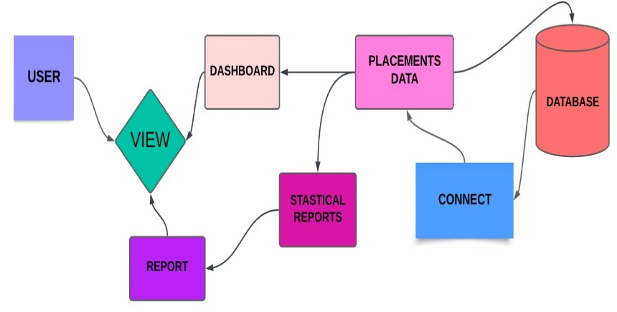**User Authentication and Security:** Implementation of user authentication and authorization mechanisms to secure the data and restrict access to authorized users

**3.4 Project Plan and Architecture**

1. **Project Plan:**

The **“Placements Analytics and Dashboard”** web application will provide a serve to guide students in choosing OnDemand technologies, aiding educational planning and efficient job searches. It offers insights into well-established hiring companies, tracking placement trends and supports data-driven decisions for institutions and for the students. For, all contributing to informed career choices in the software industry.

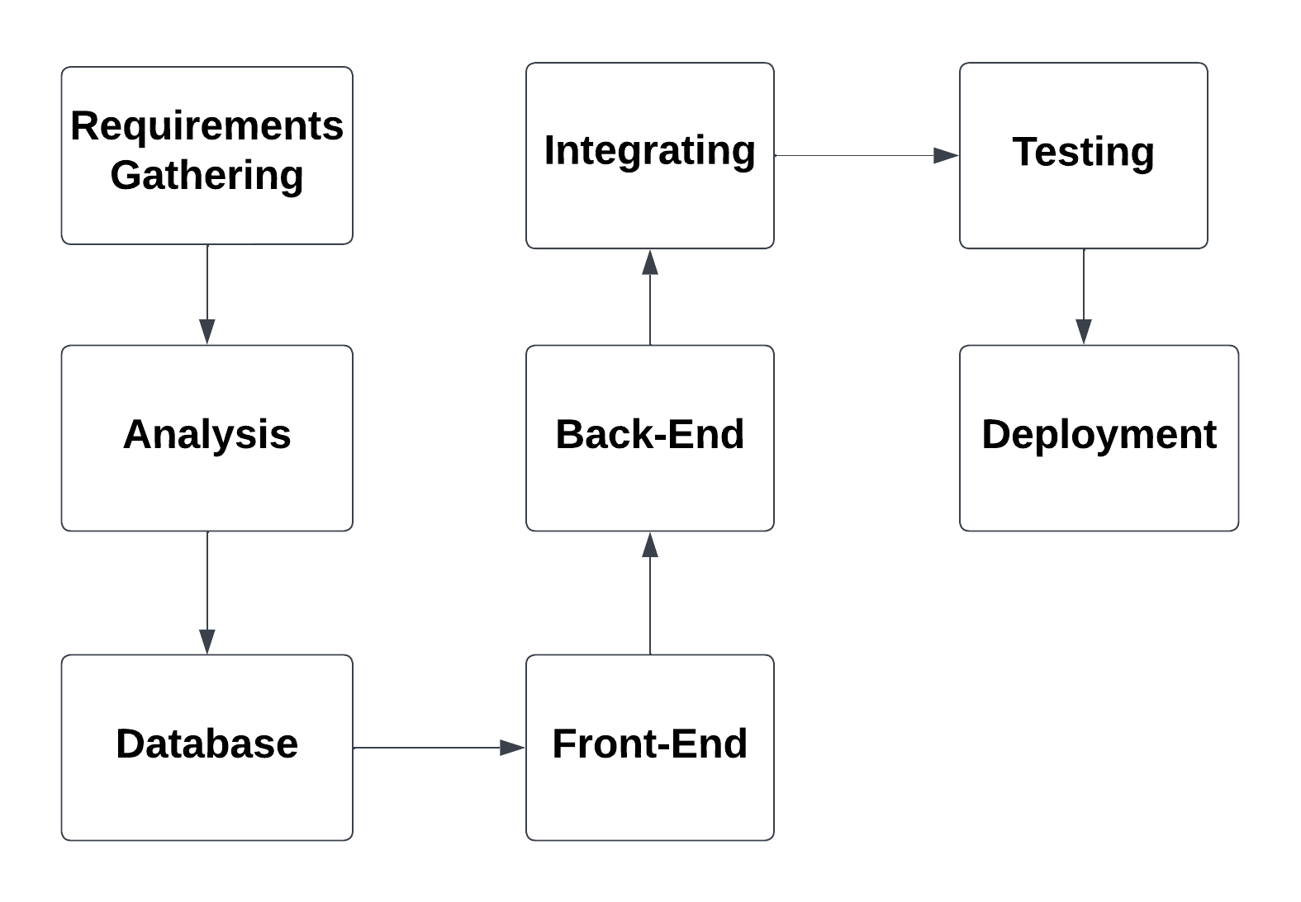

1. **System Architecture:**

The system consists of a front-end for user interaction, the back-end handling data and business logic, a relational database for data storage, an analytical engine for data analysis, a visualization component to display insights. It also includes user authentication, optional API gateway, secure hosting, scalability, monitoring and potential third-party integration, all aimed at helping students make informed career decisions in the software industry.

**4 Results and Discussions:**

From the below Provided information and from the figures are the interface provided to the user to view and search for the companies which matches his/her skill set.

**4.1 LANDING PAGE(HOME):**

The platform offers a user-friendly homepage, enabling straightforward navigation through various sections. Furthermore, users can access the dashboard to obtain insights into their placement data, analyses trends, and visualize crucial information through pie charts and bar graphs. The reports section provides comprehensive information on student performance and placement outcomes.

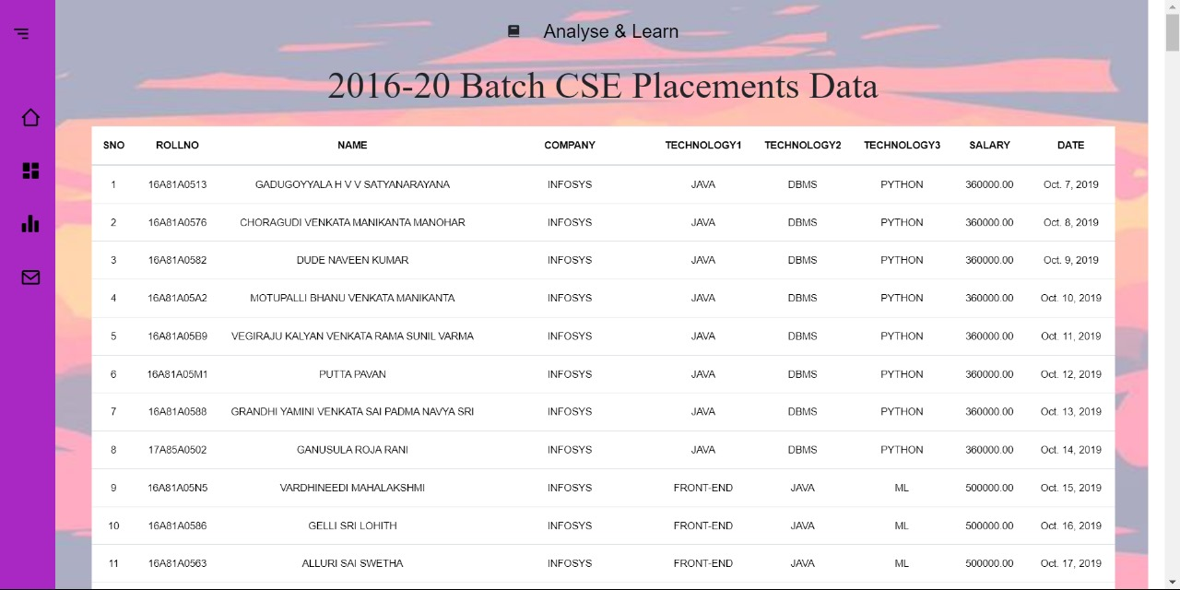

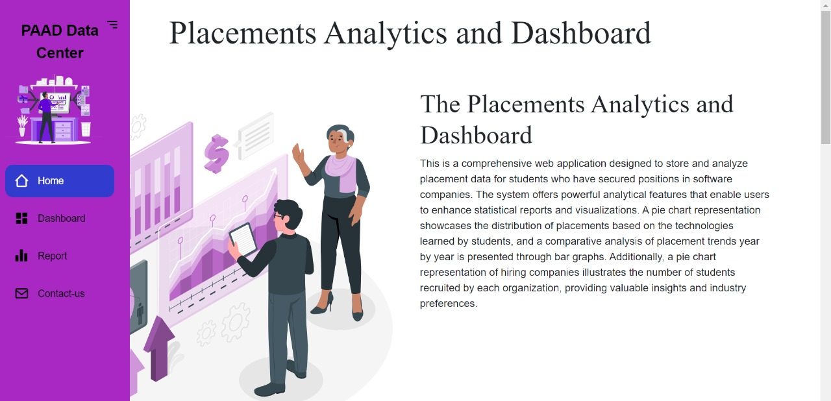

**Figure 1.1** Landing Page

**4.2 DASHBOARD:**

The "Placement Analysis and Dashboard" is a dedicated web-based application, accessible through a dedicated webpage, functioning as a repository of information concerning students who have successfully secured positions in various companies. The platform provides a wealth of data related to these students, including the number of technologies they have mastered, the organizations they are employed by, their salary information, and their employment start dates. Notably, the dashboard prominently displays individual student details, such as their names, roll numbers, employing companies, areas of technological expertise, salary particulars, and dates of joining. The primary goal of this dashboard is to offer insights into the placement of students within the Computer Science and Engineering (CSE) department during the period spanning 2016 to 2020. The key fields within the dashboard include SNo, RollNo, Name, Company, Technologies (with a focus on three main technologies), Salary, and Date of Joining.

**Figure 1.2** DashBoard

**4.3 REPORT:**

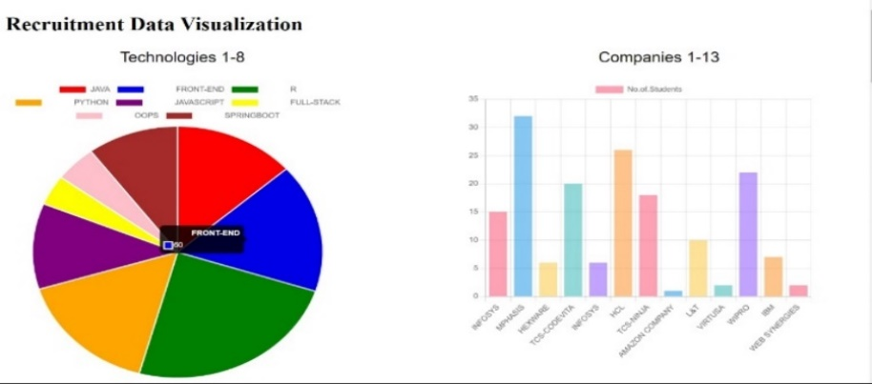In this web application, we offer information about students who have successfully landed positions in different companies, categorized by the technologies they have acquired. visualization of this information.

**Figure 1.3** Data Visualizatiion

we employ Chart.js. This powerful tool enables users to All of this data is meticulously stored in our database. To enhance the clarity and grasp the distribution of individuals across various companies and the corresponding compensation packages. We present this data through bar graphs and pie charts, making it more user-friendly and comprehensible.

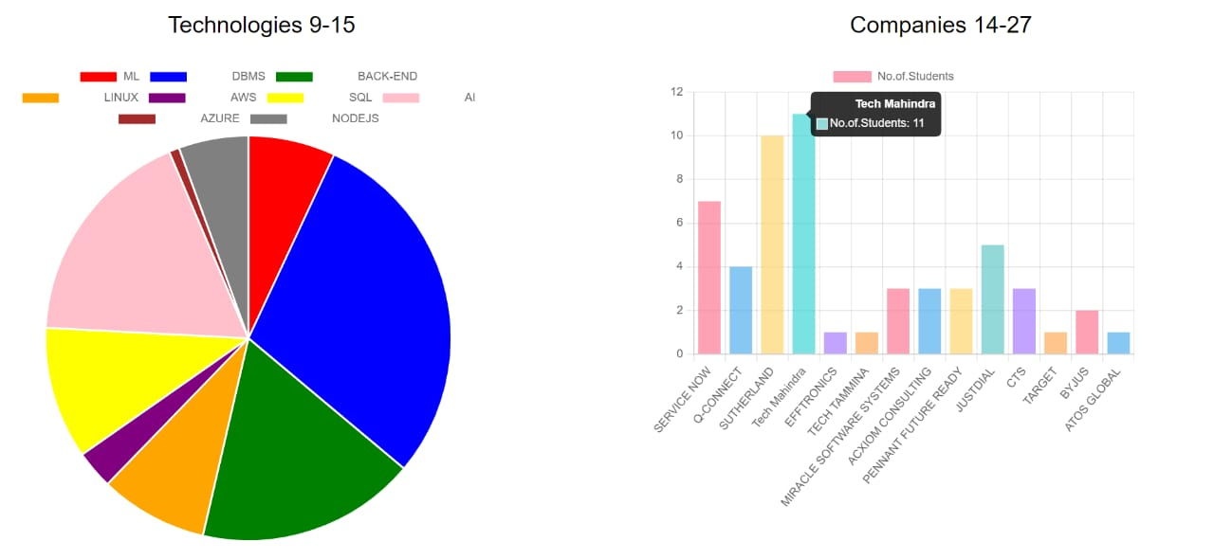

**Figure 1.3.2** Pies & BarGraphs

**4.3.1 Stacked Line Chart:**

In our analysis, we have gathered data from previous students who secured jobs in various companies within the Computer Science and Engineering (CSE) department between the years 2019-2020. We aim to understand the current recruitment trends based on past on-campus recruitments, shedding light on both growth and declines in job requirements.

To facilitate a clearer comprehension of this analysis, we employ stacked line charts for enhanced visualization. So, users can easily grasp key insights about placements, making it a convenient and informative tool for understanding the dynamics of employment opportunities. Stacked line charts provide a different perspective on the data, showing how different factors contribute to overall trends over time.

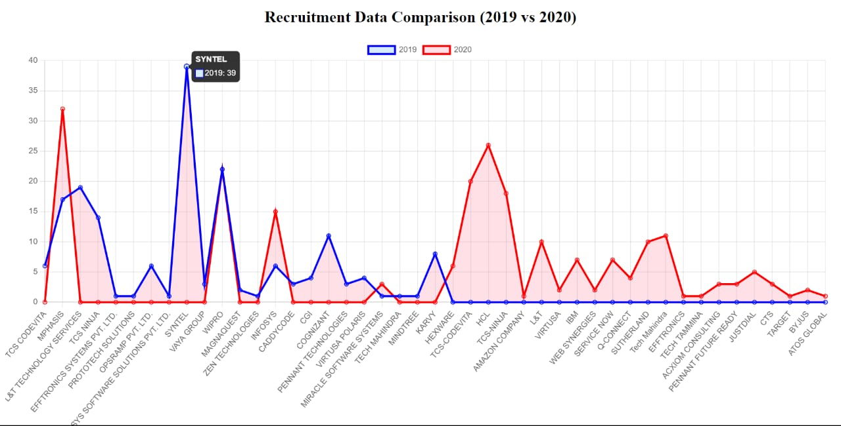

**Figure 1.3.3** Stacked Line Chart

**4.3.2 Suggestion**

We are offering essential recommendations to students through a link located on the lower left-hand side

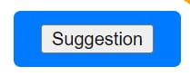

**Figure 1.3.4** Suggestion Box

The suggestion box featured in our reports serves as a valuable resource for students. Within this section, we offer insights into the top companies that have successfully hired

our students, providing a clear path to career opportunities.

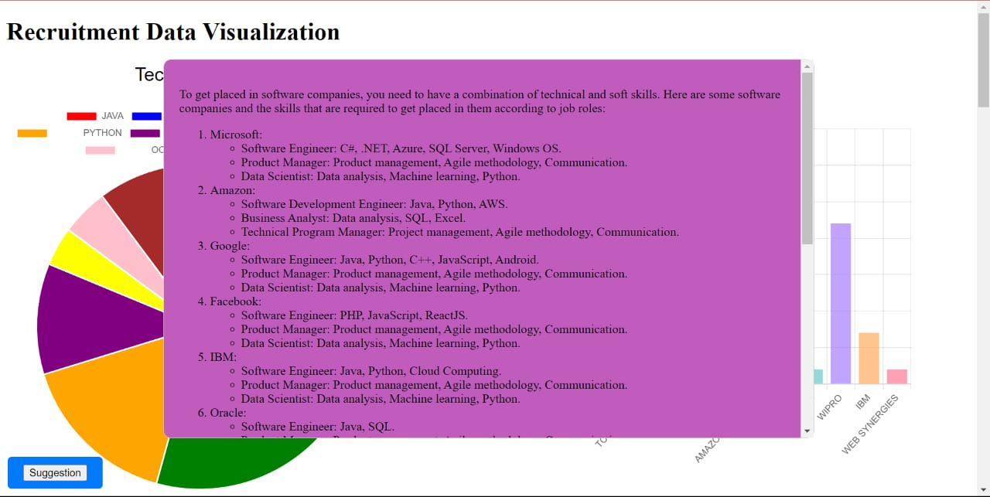

**Figure 1.3.5** Suggestions for Students

We also provide tailored recommendations, highlighting the key technologies and skills sought after by these top companies. These suggestions guide students in their educational journey, helping them acquire the necessary expertise to secure positions with these prestigious employers

**5.CONCLUSION:**

In conclusion, the **"Placements Analytics and Dashboard"** is a robust web application dedicated to storing and analyzing placement data, assisting students in their pursuit of well-established software companies. It empowers users with potent analytical features for elevating statistical reports and visualizations. A pie chart representation underscores the distribution of placements based on students' acquired skills, offering invaluable guidance for career decisions. Additionally, the project conducts a year-on-year comparative analysis of placement trends, portraying these insights through bar graphs and pie charts illustrating recruitment by various organizations. The core data-related aspects are effectively completed, and the focus now turns to enhancing the user experience through an informative homepage. This will serve as an accessible entry point for users to access placement data and insights. we provide user support for addressing queries and offering further details, ensuring a comprehensive and user-centric experience.

**5.1 FUTURE SCOPE:**

1. **Multi-Year Data Integration:** In the current scenario, the system includes only one year of placement data. In the future, the project could be enhanced to integrate multiple years of placement data. This would allow for a more comprehensive analysis of placement trends over time, enabling students and colleges to make more informed decisions.

The future scope of the project could involve aggregating placement data from different colleges. This would provide a broader view of the placement landscape and help identify industry preferences and recruitment trends on a larger scale. Students can then compare the performance of their institution with others and work on areas of improvement.

1. **Advanced Analytics:** With the addition of more data, advanced analytics and machine learning techniques can be incorporated to predict future placement trends. This would involve analyzing historical data to identify patterns and forecast which skills and technologies will be in demand in the future.
2. **Real-Time Data Updates:** The project could be upgraded to include real-time data updates. This would involve integrating the application with college placement systems to fetch data in real-time, ensuring that students and administrators always have access to the most up-to-date information.

**6. REFERENCE:**

[1] S. SATHISH1, C.R. RENE ROBIN2 “An Optimized Result Analysis System for Institutions in India having Credit System” Vol 03, Issue 01; January-April 2012 ICICES-2012-SAEC

[2] Ajay Kumar Pal 2013 Classification Model of Prediction for Placement of Students, I.J.Modern Education and Computer Science

[3] Aljohani, N. R., Daud, A., Abbasi, R. A., Alowibdi, J. S., Basheri, M., & Aslam, M. A. (2019). An integrated framework for course adapted student learning analytics dashboard. *Computers in Human Behavior*. <https://doi.org/10.1016/j.chb.2018.03.035>

[4] Chatti, M. A., Muslim, A., Guliani, M., & Guesmi, M. (2020). *The LAVA model: learning analytics meets visual analytics*. <https://doi.org/10.1007/978-3-030-47392-1_5>

[5] Verbert K, Duval E, Klerkx J, Govaerts S, Santos JL (2013) Learning analytics dashboard applications. Am Behav Sci 57(10):1500–1509

[6] *Comparative Analysis of Placement Trends in India and the US*: This paper was published in the International Journal of Advanced Research in Computer Science (IJARCS) and authored by Dr. Pooja Sharma, Dr. Anil Kumar, and Dr. Rajesh Kumar .

[7] *Data-Driven Approach to Placement Analytics*: This paper was published in the International Journal of Advanced Research in Computer Science (IJARCS) and authored by Dr. Ruchi Singh, Dr. Shailendra Singh, and Dr. Pradeep Kumar ³.